Finding Experiential Positions for Pre-Health Students
Real-life experience is a critical part of preparation for professional school. It is important that you find a position that exposes you to the human condition in all forms. This can include positions at healthcare institutions, but also charities that give you access to patients, families, and people in need. Choose an organization that serves a group about which you are passionate and take every opportunity to interact with and learn about people who are different from you. Below are some examples of institutions and jobs that may provide you with valuable experiences:
Volunteer
- Local healthcare institutions (OSUMC, OhioHealth, Mount Carmel, Nationwide Childrens’, St. Jude, nursing homes, etc.)
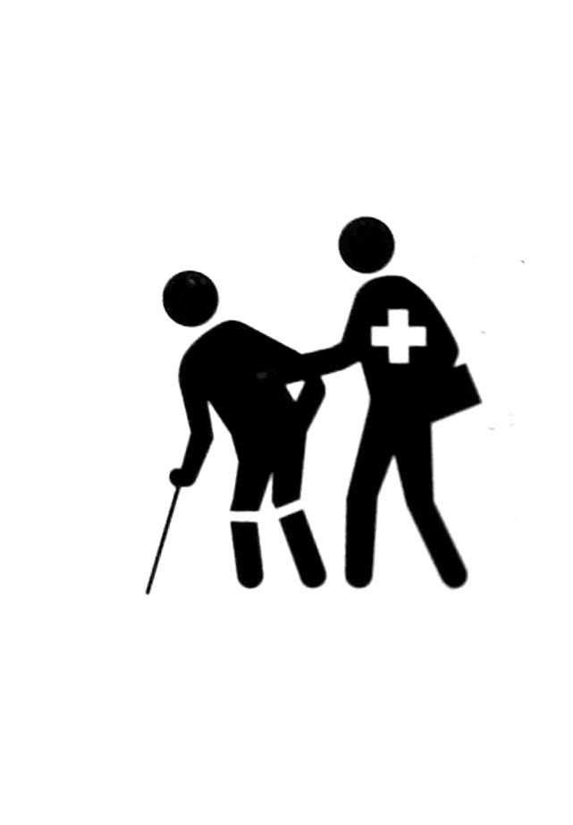
- Central Ohio American Red Cross
- Local disease-related non-profit organizations (e.g. ALS Association, MS Society, Alzheimer’s Association, Parkinson Foundation, Ohio Center for Autism, etc.)
- Columbus Coalition for the Homeless
- LifeCare Alliance
- Suicide Hotline
- MidOhio Habitat for Humanity
- Big Brothers Big Sisters of Central Ohio
- Mid-Ohio Foodbank
Work
- Patient Care Associate / Nursing Assistant
- Surgical Technician
- Phlebotomist
- Intern at healthcare institutions, non-profits, etc.
- Service with Americorps (post-graduation)
- Medical Research Assistant
- EMT
- Pharmacy Technician

